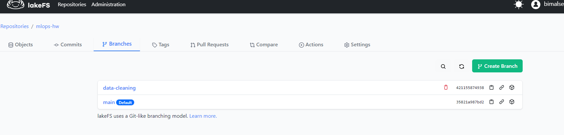

Weight and biases was fully done on the google collab notebook, but here is a screenshot.

